8th ANNUAL RETREAT

SPONSORSHIP & VENDOR OPPORTUNITIES

www.renewandrevitalize.org

March 11-12, 2022
Westin Hotel, National Harbor Hotel & Virtual
240-391-8030
info@renewandrevitalize.com
Hosted by the Renew and Revitalize Marriage & Family Institute, a 501(c)(3) non-profit organization.

CONNECT WITH MARRIED COUPLES, PROFESSIONALS, PASTORS AND QUALIFIED SPEAKERS FROM ACROSS DC, VIRGINIA, AND MARYLAND

The Renew and Revitalize Marriage & Family Institute will hold our annual Renew and Revitalize Marriage Retreat on March 11th and 12th, 2022 at the beautiful waterfront Westin Hotel, in National Harbor, MD. We expect approximately 80 attendees in-person to participate in this highly interactive and content-rich event. Some participants will be attending virtually. Vendors will be placed in highly visible spaces to allow for maximum exposure to retreat attendees.

THE IMPACT OF YOUR CONTRIBUTION

Healthy Marriage

Healthy Spouse

Healthy Children

Decreased Stress

Productive, Happy Citizens & Community

Recognizing the critical importance of healthy and productive marriage and families, the Renew and Revitalize Marriage and Family Institute (a 501(c)3 non-profit organization) seeks to positively affect our communities by providing critical resources to strengthen and repair marriage and families. We educate, encourage, and empower couples and families to live functionally, productive and fulfilled in their relationships. We offer marriage conferences/retreats, coaching, marriage, and premarital counseling as well as; family trainings, individual/group, family counseling sessions; and child & family empowerment programs. The goal is to influence the significant reduction in the divorce rate and influence the significant increase in the number of healthy marriages and families. Achieving this goal will lead to healthy individuals, couples and families and healthier communities overall.
Your sponsorship will make a difference in the lives of couples and children by supporting the programs that will provide them with valuable resources to strengthen and repair their marriage and family relationships!

PRE-RETREAT MARKETING: BE SURE TO COMMIT EARLY TO TAKE FULL ADVANTAGE!

WEBSITE: www.renewandrevitalize.org
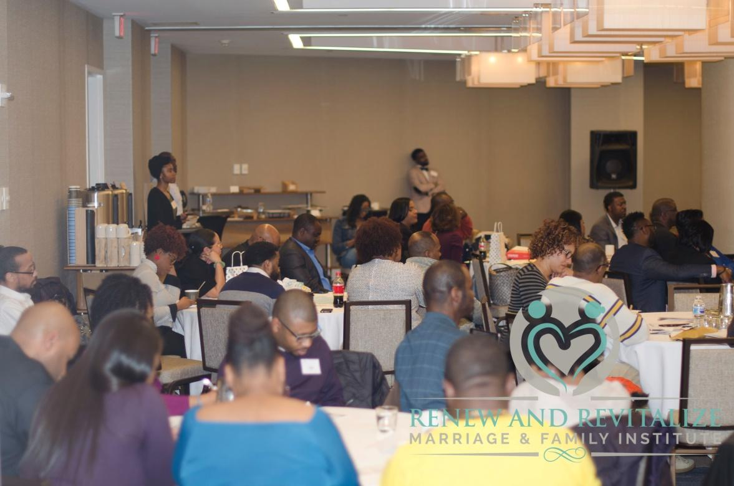

- Event promotion and sponsor recognition
- Retreat wrap-up and sponsor acknowledgment

EMAIL:
- Regular event marketing email blasts
- Sponsor and Exhibitors preview email sent prior to the event to all registered attendees

SOCIAL MEDIA:
- Reach our social media followers directly!
- Event promotion on Renew and Revitalize Marriage Retreat’s Facebook, Twitter, and Instagram sites.
- Additional updates and announcements of speakers, programming, sponsors, and related topics.

OVERVIEW OF SPONSORSHIP OPTIONS

- 2022 RETREAT HEADLINE SPONSOR ($15,000)
- BANKING SPONSOR ($10,000)
- DESSERT RECEPTION SPONSOR ($5000)
- OPENING REMARKS ($2500)
- VIDEOGRAPHY SPONSOR-($2000)
- PHOTOGRAPHY SPONSOR ($2000)
- GIFT BAG SPONSOR ($1000)
- ELITE SPONSOR ($800)
- PLATINUM SPONSOR ($500)
- GOLD SPONSOR ($215) (VENDOR)
- SILVER SPONSOR ($100)

SPONSORSHIP & VENDOR DETAILS

RETREAT HEADLINE SPONSOR ($15,000)
- 10 minutes for Plenary remarks from podium prior to keynote speaker
- Preferred placement in the vendor area to ensure maximum traffic
- 5 complimentary retreat in-person or virtual registrations
- 4 x 6 ad in the program book
- Dedicated email blast showcasing your organization prior to the retreat
- Exclusive email list of retreat attendees event
- Opportunity to provide a guest blog on The Renew and Revitalize Marriage and Family Institute Facebook page and promotion on social media
- Logo on retreat webpage
- Logo on onsite retreat signage
- Listing on the program as the Retreat Headline Sponsor
- Vendor table (GOLD sponsorship) to display company information and products
BANKING SPONSOR ($10,000)
- 45 minute “Financial Success in Marriage” breakout workshop session
- Preferred placement in the vendor area to ensure maximum traffic
- 5 complimentary retreat in-person or virtual registrations
- 4 x 6 ad in the program book
- Dedicated email blast showcasing your organization prior to the retreat
- Exclusive email list of retreat attendees following event
- Opportunity to provide a guest blog on The Renew and Revitalize Marriage and Family Institute Facebook page and promotion on social media
- Logo on retreat webpage
- Logo on onsite retreat signage
- Listing on the program as the Banking Sponsor
- Vendor table (GOLD sponsorship) to display company information and products

DESSERT RECEPTION SPONSOR ($5000)
- You will have the opportunity to make brief remarks (up to 8 minutes) about your company and its commitment to marriage and families in the community during the Dessert Reception on Friday Evening!
- 3 complimentary retreat in-person or virtual registrations
- 4 x 6 ad in the program book
- Listing on the program as the Dessert Sponsor
- Logo on retreat webpage
- Logo on onsite retreat signage
- Vendor table (GOLD sponsorship) to display company products

OPENING REMARKS ($2500)
- Make a great first impression with attendees by sponsoring the opening remarks. Your sponsorship includes recognition by the opening speaker and will be part of the very first words spoken at the event on Saturday!
- Listing on the program as the Opening Remarks Sponsor
- 2 complimentary retreat in-person or virtual registrations
- 4 x 6 ad in the program book
- Logo on retreat webpage
- Logo on onsite retreat signage
- Vendor table (GOLD sponsorship) to display company information and products
VIDEOGRAPHY & PHOTOGRAPHY SPONSOR- ($2000)
- Your organization will be a part of capturing the treasures of the retreat in the form of videos and pictures!
- Listing on the program as the Videography & Photography Sponsor
- 2 complimentary retreat in-person or virtual registrations
- 4 x 6 ad in the program book
- Logo on retreat webpage
- Logo on onsite retreat signage
- Vendor table (GOLD sponsorship) to display company information and products
GIFT BAG SPONSOR- ($1000)
- People love gifts! You will be recognized as the valuable sponsor who supplied them with all of the goodies in the retreat gift bags!
- 1 complimentary retreat in-person or virtual registration
- 4 x 6 ad in the program book
- Logo on retreat webpage
- Logo on onsite retreat signage
- Vendor table (GOLD sponsorship) to display company information and products

ELITE SPONSOR- ($800)
- You are an advocate, colleague, or partner in the goal of strengthening marriages and you’d like to receive recognition for helping to support our retreat and attendees.
- 1 complimentary retreat in-person or virtual registration
- Logo on retreat webpage
- Logo on onsite retreat signage
- 2 x 3 ad in the program book
- Vendor table (GOLD sponsorship) to display company information and products

PLATINUM SPONSOR- ($500)
- You are an avid supporter of marriage and families and you want to show it through supporting our retreat!
- 1 complimentary retreat in-person or virtual registration
- Logo on retreat webpage
- 2 x 3 ad in the program book
- Vendor table (GOLD sponsorship) to display company information and products

GOLD SPONSOR (VENDOR)- ($215)
- Vendor table to display company information and products
- Company name listed in program book
- Business cards and item of choice may be added to the gift bags given to attendees

SILVER SPONSOR- ($100)
- Company name listed in program book
- Business cards and item of choice may be added to the gift bags given to attendees

TERMS AND CONDITIONS

PAYMENT
Vendors and sponsorship are available on a first-come, first-served basis. Payment in full is due along with the vendor/sponsorship registration form. Vendor and Sponsorship fees are non-refundable. Vendors and sponsor organizations must be approved by Renew and Revitalize Marriage & Family Institute.

VENDOR INFORMATION
Vendor spaces include one 6-foot table. The Renew and Revitalize Marriage & Family Institute reserves the right, at its sole discretion, to designate vendor space or make changes in the location, size, layout, arrangement, and display limits of the exhibits. Placement of the Vendor/Sponsor is contingent on the level of sponsorship and in the order in which payment in full is received. Although not guaranteed, we do our best not to place competitors directly next to or adjacent to each other in the limited space available.
The Vendor/Sponsor understands table set-up times are not negotiable. The vendor/sponsor may arrive as early as 5pm on Friday and must be set up by no later than 6:30pm on Friday. Failure to set up by 6:30pm on Friday may result in a less desirable vendor space without consideration towards refund of paid fees. Breakdown of vendor tables may not begin prior to 4:00pm on Saturday and must be completed by 5pm.

FORCE MAJEURE
The Renew and Revitalize Marriage & Family Institute shall not be held responsible for any loss, damage, or delay due to occurrence of any circumstances beyond the control of our organization-such as acts of God, war, government regulations, disaster, strikes, civil disorder, or curtailment of transportation facilities-to the extent that such circumstances makes it illegal or impossible to provide or use the venue’s facilities.

Contact us at 240-391-8030 or info@renewandrevitalize.com for more information.

SPONSORSHIP REGISTRATION FORM

Full Name:________________________________________________________
Company name: ___________________________________________________
Company address: _________________________________________________
Contact phone number: _____________________________________________
Email address: ____________________________________________________
Number of people attending: ___________________________________________
Sponsorship Package: (please check selected package)
Retreat Headline Sponsor ____
Dessert Reception _____ Banking _____
Opening Remarks ____ Videography _____ Photography _____
Gift Bag _____ Elite _____
Platinum ____ Gold (VENDOR) _____ Silver _____
Payment information:
Credit card: Visa ____ MasterCard ____ AMEX____
Credit card number: _______________________________________________
Authorized signature: ______________________________________________
Billing address: ___________________________________________________
Security Code on Back of Card (Last 3 digits) ___________
Expiration Date__________
Checks: Please make checks payable to Renew and Revitalize Marriage & Family Institute
To submit your registration form, please email your completed form to info@renewandrevitalize.com, fax it to 240-667-7188, or mail your completed form and check to 7305 Baltimore Avenue, Suite 307, College Park, MD 20740. You may also pay via PayPal using the email address info@renewandrevitalize.com. Hosted by the Renew and Revitalize Marriage & Family Institute, a 501(c)(3) non-profit organization.

